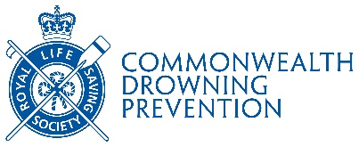

COMMONWEALTH RESEARCH HONOUR NOMINATION FORM

This honour recognises a leading drowning prevention researcher whose achievements have significantly impacted on the Society and its work and have contributed to our global drowning prevention mission.
Closing date for nominations is 31st March
Successful nominees will be awarded on 25th July

Nominating Member Branch or County: ….……………………………………………

Name of Nominee: .…………………………………………………………………………………

Nominee’s Previous Diploma Award

Title:

Date:

Please provide a detailed description of the contribution your nominee has carried out along with links to any published articles/ research articles that support this nomination (including links to google schola, ORCID, ResearchGate or Scopus pages etc if applicable)

Please provide a summary statement that could be used on our social media platforms if the nominee is successful (Max 150 words):

Branch Signatory Name: ……..………………………………………….

Branch Signatory Position: …..…………………………………

Authorized Branch Signature: ………………………………………………………………… Date: ...........................

